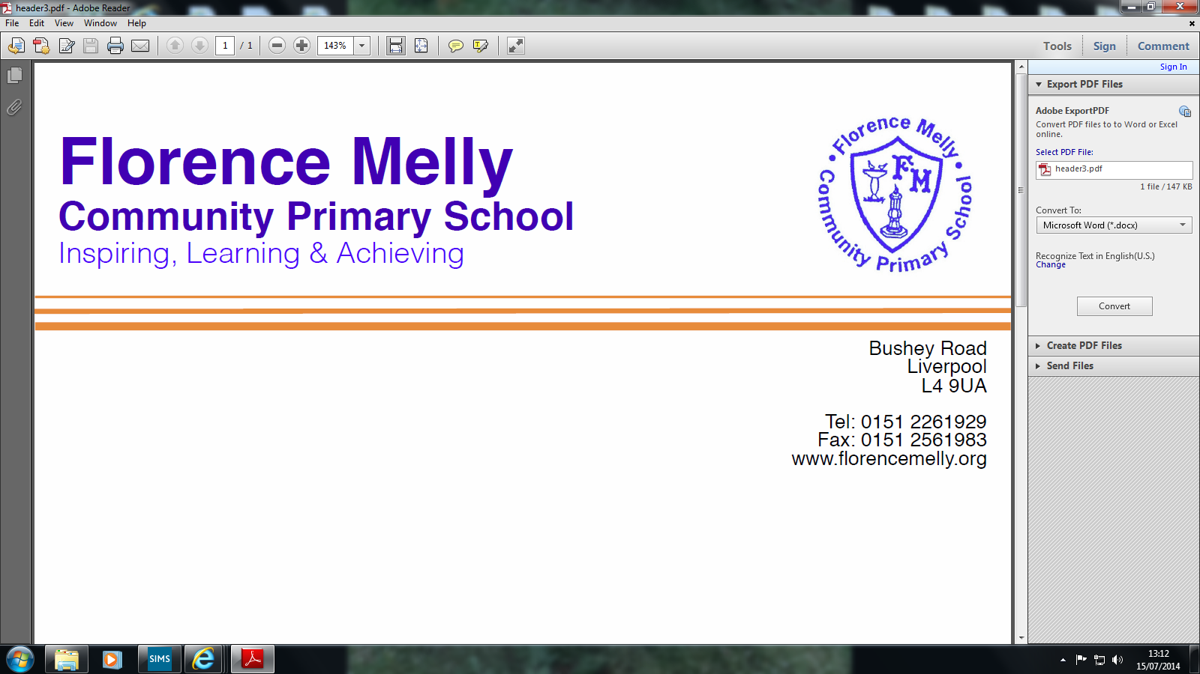

Thursday 6th April 2017

Dear Parents/Carers,

I would like to take this opportunity to thank all of our pupils for their hard work and achievements over the last term. I would also like to thank all of our parents/carers for your support and encouragement given to pupils and staff alike during what is always a busy and productive term from Christmas to Easter.

We have enjoyed every class participating in whole school assemblies and curriculum projects. Highlights of the term have included a very successful Science Week, World Book Day and a number of educational visits. Can I also thank you for your generosity with supporting a number of fund raising events such as Red Nose day and for attending the parents meeting on 20th March. Your support helps us to encourage all of our pupils to achieve to the best of their ability and develop as responsible, caring young people who contribute most effectively to Florence Melly Community Primary School and our local community. Please take some time to read what is contained in our newsletter on the school website and should you wish to discuss anything arising from the contents or any issues relating to your child please do not hesitate to contact me. I will always make time to see you.

Monday 24th April is a training day for staff so **pupils will be back in school on Tuesday 25th April** when the new term begins. We look forward to seeing all of our children refreshed and eager to learn in the summer term.

In the summer term there will be lots of trips out for your children as part of our curriculum which encourages them to learn about our city. We also look forward to working closely with **PATCH** in celebrating the 90th anniversary of the opening of our school with some exciting events that we have planned for July 2017.

I would like to wish you all a happy Easter and hope you have an enjoyable and safe Easter break.

Best wishes



Ken Heaton

**Headteacher**